C01 ASSESSMENT TOOL-3
NAME: P ROHINI
REG NO: 192524147
COURSE CODE: CSA0307
COURSE NAME:DATA STRUCTURE
1).
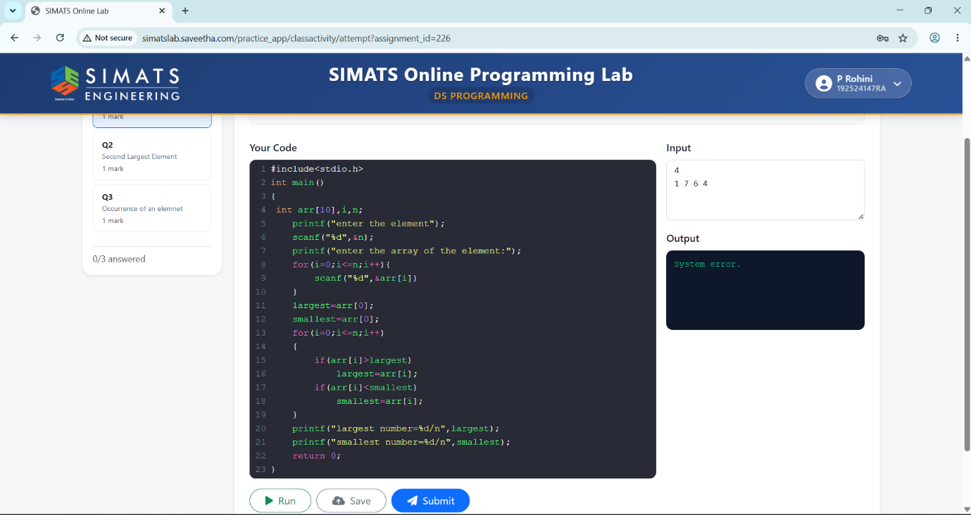
2).
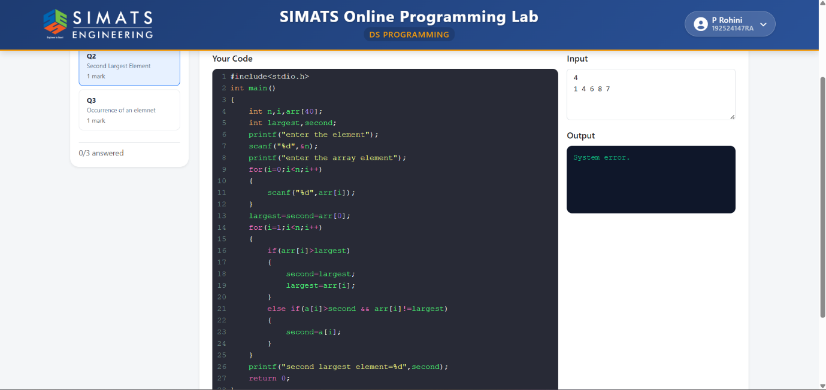
3).
